AIAC - Lab Assignment : 5.1 & 6 (Classes & Responsible AI)

Name Thrishnak Enrollment No : 2303A52013 Batch : 31

Task 1:
Employee Data: Create Python code that defines a class named
with the following attributes: , ,
Employee
empid
empname
basic_salary
exp

,
designation
display_details()
, and
. Implement a method

method
to print all employee details. Implement another to determine additional allowance

based on experience:
calculate_allowance()

- If
- If
- If
→ allowance = 20% of
→ allowance = 10% of
exp > 10 years
basic_salary
5 ≤ exp ≤ 10 years
basic_salary
→ allowance = 5% of
exp < 5 years
basic_salary

Finally, create at least one instance of the class, call the
Employee
method, and print the calculated allowance.
display_details()

Code:

class Employee:
def init (self, empid, empname,designation,basic_salar y,exp):
self.empid empid self.empname empname self.designation = designation
=
=

Output:

Task 2:
Electricity Bill Calculation- Create Python code that defines a class
customer_id

named
with attributes:
. Implement a method
ElectricityBill
units_consumed
display_details()
, name , and
to print

customer details, and a method
calculate_bill()
- Units ≤ 100 → ₹5 per unit
- 101 to 300 units → ₹7 per unit
- More than 300 units → ₹10 per unit
where:

Create a bill object, display details, and print the total bill amount.
self.basic_salary
self.exp = exp
basic_salary
def calculate_salary(self): if self.exp > 10:
allowance 0.2 * self.basic_salary
elif 5<= self.exp <= 10:
allowance elif self.exp
allowance
total_salary
0.1 * self.basic_salary
5:
0.05
self.basic_salary
self.basic_salary
allowance
return total_salary
#example usage
emp1
Employee(101, "Alice", "Manager", 50000, 12 )
print(f"Total salary for {emp1.empname}: {emp1.calculate_sala
ry()}")
=
+
=
*
=
<
=
=
=

Code:

class ElectricityBill:
def calculate_bill(self, customer_id, name, units_consume d, rate_per_unit):
self.customer_id = customer_id
self.name name
=
self.units_consumed = units_consumed
self.rate_per_unit rate_per_unit
=

if self.units_consumed <= 100:
bill_amount self.units_consumed 5
*
=
elif 101 <= self.units_consumed <= 300:
-
+
=

100)
bill_amount
7)
*
(100 * 5)
((self.units_consumed

elif self.units_consumed 300:
*
+
=
>

bill_amount
*
-
(100 * 5)
(200
7) + ((self.unit

s_consumed
300)
10)

return bill_amount customer1= ElectricityBill()
customer1.calculate_bill(101, "Alice", 350, 0) print(f"Customer ID: {customer1.customer_id}") print(f"Customer Name: {customer1.name}") print(f"Units Consumed: {customer1.units_consumed}")
print(f"Total Bill Amount: {customer1.calculate_bill(101, 'Al ice', 350, 0)}")

Output:

Task 3:
Product Discount Calculation- Create Python code that defines a

class named
, and
price
category
with attributes: product_id , ,
. Implement a method to
Product
product_name
display_details()

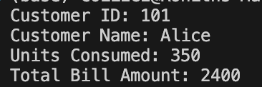
print product details. Implement another method
where:
calculate_discount()
- Electronics → 10% discount
- Clothing → 15% discount
- Grocery → 5% discount
Create at least one product object, display details, and print the final price after discount.

Code:
class Product:
def init (self, product_id, product_name, price, categ ory):
self.product_id product_id self.name product_name self.price price
self.category category
def calculate_discount(self):
if self.category == "Electronics":
=
=
=
=

return self.price 0.90 # 10% discount
*
elif self.category == "Clothing":
return self.price 0.80 # 20% discount
*
elif self.category == "Grocery":
return self.price 0.95 # 5% discount
*
return self.price # No discount

# Creating object (outside the class)
bill1 = Product(101, "Laptop", 1000, "Electronics")

discounted_price = bill1.calculate_discount() print(f"Product Name: {bill1.name}") print(f"Product ID: {bill1.product_id}") print(f"Product Category: {bill1.category}") print(f"Original Price: {bill1.price}") print(f"Price after Discount is {discounted_price}")

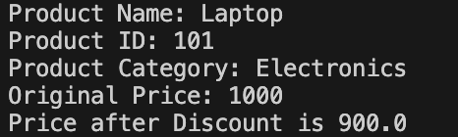
Output:

Task 4:
Book Late Fee Calculation- Create Python code that defines a class
LibraryBook
book_id
title
author

named
with attributes:
,
, ,

, and . Implement a method
borrower
days_late
display_details()
calculate_late_fee()

to print book details, and a method
- Days late ≤ 5 → ₹5 per day
where:

- 6 to 10 days late → ₹7 per day
- More than 10 days late → ₹10 per day
Create a book object, display details, and print the late fee.

Code:

class LibraryBook:
def init (self, book_id, title, author, borrower, days
_late):
=

self.book_id self.title
=
book_id title

self.author = author
self.borrower borrower
=
self.days_late = days_late

def display_details(self): print(f"Book ID: {self.book_id}") print(f"Title: {self.title}") print(f"Author: {self.author}") print(f"Borrower: {self.borrower}")
print(f"Days Late: {self.days_late}")

def calculate_late_fee(self): if self.days_late <= 5:
return self.days_late * 5 elif self.days_late <= 10:
return self.days_late * 7 else:
return self.days_late * 10

# Creating object (outside the class)
book1 = LibraryBook(201, "Python Programming", "Guido van Ros sum", "Alice", 8)

# Displaying details
book1.display_details()
# Calculating and printing late fee late_fee = book1.calculate_late_fee()
print(f"Late Fee: ₹{late_fee}")

Output:
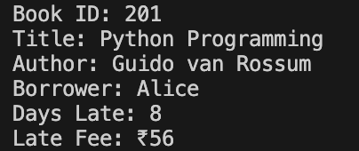

Task 5:
Student Performance Report - Define a function
that accepts a dictionary containing student names and their marks. The function should:
student_report(student_data)
- Calculate the average score for each student
- Determine pass/fail status (pass ≥ 40)
- Return a summary report as a list of dictionaries
Use Copilot suggestions as you build the function and format the output.

Code:

def student_report(student_data): report []
=

for name, marks in student_data.items():
# Handle marks given as list or dictionary if isinstance(marks, dict):
=
=

scores else:
scores
marks.values() marks

average
sum(scores)
len(scores)

status = "Pass" if average >= 40 else "Fail"
/
=

report.append({ "name": name,
"average_score": round(average, 2), "status": status
})

return report # Example usage students = {
"Alice": [45, 50, 40],
"Bob": [30, 35, 38],
"Charlie": {"Math": 60, "Science": 55, "English": 65}
}

summary student_report(students)
=

for student in summary: print(student)

Output:

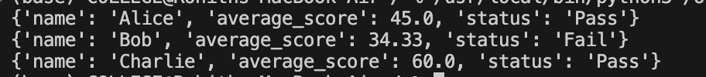

Task 6:
Taxi Fare Calculation-Create Python code that defines a class named
ride_id
driver_name
distance_km

with attributes:
TaxiRide
,
, ,

and . Implement a method to
waiting_time_min
display_details()

print ride details, and a method
calculate_fare()
- ₹15 per km for the first 10 km
- ₹12 per km for the next 20 km
- ₹10 per km above 30 km
- Waiting charge: ₹2 per minute
where:

Create a ride object, display details, and print the total fare.

Code:

class TaxiRide:
def init (self, ride_id, driver_name, distance_km, wai ting_time_min):
=
self.ride_id ride_id
self.driver_name = driver_name self.distance_km = distance_km
=
self.waiting_time_min waiting_time_min

s")
def display_details(self): print(f"Ride ID: {self.ride_id}")
print(f"Driver Name: {self.driver_name}") print(f"Distance Travelled: {self.distance_km} km") print(f"Waiting Time: {self.waiting_time_min} minute

def calculate_fare(self):
fare 0
=

# Distance fare calculation if self.distance_km <= 10:
fare += self.distance_km elif self.distance_km <= 30:
fare += 10 * 15
fare += (self.distance_km else:
fare += 10 * 15
fare += 20 * 12
fare += (self.distance_km
15
10)
12
30)
10
# Waiting charge
fare += self.waiting_time_min
2
return fare
# Creating object (outside the class)
ride1 = TaxiRide(101, "Rahul", 35, 10)
# Displaying details
ride1.display_details()
# Calculating and printing total fare total_fare ride1.calculate_fare()
print(f"Total Fare: ₹{total_fare}")
=
*
*
-
*
-
*

Output:

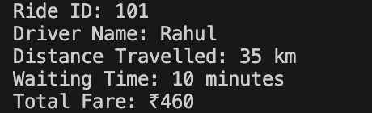

Task 7:
Statistics Subject Performance - Create a Python function
that accepts a list of 60 student scores and computes key performance statistics. The function should return the following:
statistics_subject(scores_list)
- Highest score in the class
- Lowest score in the class
- Class average score
- Number of students passed (score ≥ 40)
- Number of students failed (score < 40)
Allow Copilot to assist with aggregations and logic Code:
def statistics_subject(scores_list): if len(scores_list) != 60:
print("Error: The list must contain exactly 60 studen t scores.")
return None
highest_score
max(scores_list)
lowest_score = min(scores_list)
average_score sum(scores_list) len(scores_list)
passed_students = sum(1 for score in scores_list if score
>= 40)
failed_students = sum(1 for score in scores_list if score
/
=
=

40)
return {
"Highest Score": highest_score, "Lowest Score": lowest_score, "Average Score": average_score, "Passed Students": passed_students, "Failed Students": failed_students
}
# Example usage
]
result
statistics_subject(scores)
if result:
for key, value in result.items(): print(f"{key}: {value}")
=
<

scores | = [
45, | 67, | 89, | 34, | 56, | 78, | 90, | 23, | 41, | 55,
62, | 38, | 49, | 71, | 84, | 29, | 65, | 77, | 58, | 40,
69, | 73, | 81, | 92, | 36, | 47, | 59, | 68, | 75, | 88,
33, | 44, | 52, | 61, | 70, | 79, | 85, | 91, | 28, | 39,
46, | 54, | 63, | 72, | 80, | 87, | 93, | 31, | 42, | 50,
57, | 66, | 74, | 82, | 86, | 95, | 27, | 35, | 48, | 60

Ouput:

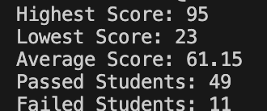

Task Description #8 (Transparency in Algorithm Optimization) Task: Use AI to generate two solutions for checking prime numbers:
- Naive approach(basic)
- Optimized approach Prompt:
“Generate Python code for two prime-checking methods and explain how the optimized version improves performance.”
Expected Output:
- Code for both methods.
- Transparent explanation of time complexity.
- Comparison highlighting efficiency improvements. Code:

#Generate Python code for two prime-checking methods and expl ain how the optimized version improves performance
def is_prime_basic(n):
"""Check if a number is prime using a basic method.""" if n <= 1:
return False
for i in range(2, n): if n % i == 0:
return False return True
def is_prime_optimized(n):
"""Check if a number is prime using an optimized metho d."""
if n <= 1:
return False

if n <= 3:
return True
if n % 2 == 0 or n % 3 == 0: return False
i = 5
while i * i <= n:
if n % i == 0 or n % (i + 2) == 0: return False
i += 6
return True
# Explanation of optimization:
# The basic method checks for factors from 2 to n-1, which re sults in O(n) time complexity.
# The optimized method reduces the number of checks significa ntly:
# 1. It first eliminates even numbers and multiples of 3 righ t away.
# 2. It only checks for factors up to the square root of n, s ince if n is divisible by any number larger than its square r oot, the corresponding factor must be smaller than the square root.
# 3. It checks only numbers of the form 6k ± 1, as all prime numbers greater than 3 can be expressed in this form.
# These optimizations reduce the time complexity to O(√n), ma king the optimized method much faster for larger numbers.

#example usage
print(is_prime_basic(17)) # Output: True print(is_prime_optimized(17)) # Output: True

Output:

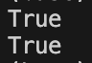

Task Description #9 (Transparency in Recursive Algorithms) Objective: Use AI to generate a recursive function to calculate Fibonacci numbers.
Instructions:
- Ask AI to add clear comments explaining recursion.
- Ask AI to explain base cases and recursive calls. Expected Output:
  - Well-commented recursive code.
  - Clear explanation of how recursion works.
  - Verification that explanation matches actual execution. Code:
#generate well commented code for fibonacci series using recu rsion and try to generate proper justification to handle test cases also
def fibonacci(n): """
This function returns the nth Fibonacci number using recu
rsion.
Parameters:
n (int): The position in the Fibonacci series to retriev
e. Must be a non-negative integer.
Returns:
int: The nth Fibonacci number.

Raises:
ValueError: If n is a negative integer. """

# Check for invalid input if n < 0:
raise ValueError("Input must be a non-negative intege
r.")

# Base case: the first two Fibonacci numbers if n == 0:
return 0 elif n == 1:
return 1

ers
# Recursive case: sum of the two preceding Fibonacci numb

return fibonacci(n - 1) + fibonacci(n - 2)

# Test cases to validate the function if name == " main ":
test_cases = [0, 1, 2, 3, 4, 5, 10, 15]

for case in test_cases:
print(f"Fibonacci({case}) = {fibonacci(case)}")

# Testing invalid input try:
print(fibonacci(-1)) except ValueError as e:
print(e) # Expected output: Input must be a non-nega tive integer.

Output:

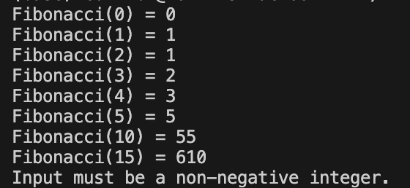

Task Description #10 (Transparency in Error Handling)
Task: Use AI to generate a Python program that reads a file and processes data.
Prompt:
“Generate code with proper error handling and clear explanations for each exception.”
Expected Output:
- Code with meaningful exception handling.
- Clear comments explaining each error scenario.
- Validation that explanations align with runtime behavior. Code:

#Generate code with proper error handling and clear explanati ons for each exception
class AIACError(Exception):
"""Base class for exceptions in AIAC module.""" pass
class InvalidInputError(AIACError): """Exception raised for invalid inputs."""

def init (self, message="The input provided is invali d."):
=
self.message message
super(). init (self.message) class CalculationError(AIACError):
"""Exception raised for errors during calculations.""" def init (self, message="An error occurred during calc
ulation."):
self.message message
=
super(). init (self.message) class DataNotFoundError(AIACError):
"""Exception raised when required data is not found.""" def init (self, message="Required data not found."):
=
self.message message
super(). init (self.message)
# Example function demonstrating the use of custom exceptions def perform_calculation(data):
if data is None:
raise DataNotFoundError("No data provided for calcula
tion.")
if not isinstance(data, (int, float)):
raise InvalidInputError("Input must be a number.") try:
/
result = 100 data # Example calculation
except ZeroDivisionError:
raise CalculationError("Division by zero is not allow
ed.")
return result # Example usage try:
print(perform_calculation(0)) except AIACError as e:
print(f"Error: {e}")

Output:

